EXPERIMENT NO. 8

AIM :- To write a lex program for separating integers, floating point numbers and reserve words from a file.

ALGORITHM:-

Letter → [a-z][A-Z]

Digit→ 0|1|2|3|4|5|6|7|8|9

Operator→+|-|\*|/|=

Integer→(Digit)+

Identifier→Letter|(Letter|Digit)+

Reserve→”MAIN”| “END”|”FOR”

1. Define file related structure.
2. Check whether the file name is provided at command line while executing the program. If not display error message and exit the program
3. Try to open the file in input mode. If file opening fails display error message and exit the program.
4. Set the file as source for input.
5. Compile the program with flex. The output will be “lex.yy.c”
6. Compile lex.yy.c with the help of gcc compiler include –l switch for lex libraries.
7. Execute the executable file ./a.out test.txt
8. test.txt file will be lexically analyzed

CODE:-

LEX PROGRAM:-

%{

#include<stdio.h>

%}

DIGIT [0-9]

%%

{DIGIT}\* {ECHO;printf(" Integer");}

{DIGIT}\*?\.{DIGIT}\* {ECHO;printf(" Float ");}

%%

int main()

{

yylex();

return 0;

}

OUTPUT:-

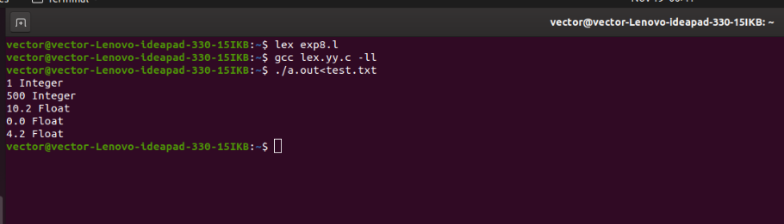

RESULT:- Thus, a lex program for separating integers, floating point numbers and reserve words from a file has been successfully executed.